Software Requirements Specification
for
Flora
Version 1.0 approved
Prepared by
- SoumyaRaj Biswal (075)
- Nitesh Kumar Debata (042)
- Sanat Kumar Nayak (089)
- Ajit Kumar Sahu (110)
Organization: Gandhi Engineering College
Submitted on: March 25th, 2021
Table of Contents
Table of Contents ii
Revision History ii
1. Introduction 1
1.1 Purpose 1
1.2 Document Conventions 1
1.3 Intended Audience and Reading Suggestions 1
1.4 Product Scope 1
1.5 References 1
2. Overall Description 2
2.1 Product Perspective 2
2.2 Product Functions 2
2.3 User Classes and Characteristics 2
2.4 Operating Environment 2
2.5 Design and Implementation Constraints 2
2.6 User Documentation 2
2.7 Assumptions and Dependencies 3
3. External Interface Requirements 3
3.1 User Interfaces 3
3.2 Hardware Interfaces 3
3.3 Software Interfaces 3
3.4 Communications Interfaces 3
4. System Features 4
4.1 System Feature 4
5. Other Nonfunctional Requirements 4
5.1 Performance Requirements 4
5.2 Safety Requirements 5
5.3 Security Requirements 5
5.4 Software Quality Attributes 5
5.5 Business Rules 5
6. Other Requirements 5
Appendix A: Glossary 5
Appendix B: Analysis Models 5

Revision History
Name | Date | Reason For Changes | Version
Flora | 25/03 | First Version | 1.0

Introduction

Purpose
Defining and describing the functions and specifications of the Flora E-commerce website is the primary goal of this Software Requirements Specification (SRS).
This Software Requirements Specification illustrates, in clear terms, the system’s primary uses and required functionality as specified by our customer.

Document Conventions
- Conventions

Convention for main title:
      - Font Face : Times
      - Font Style: Bold
      - Font Size: 18

Convention for sub title:
  - Font Face: Times
  - Font Style: Bold
  - Font Size: 14

Convention for body:
- Font Face: Arial
- Font Style: Italic
- Font Size: 11

Intended Audience and Reading Suggestions
We are making this document by keeping in mind different types of readers. This document will be useful for different audience in various ways. So it is suggested to read the document in the prescribed order

Audience | Use
Developers | They will use this document for guidance for design and implementation phase.
Marketing Staff | They can use this document to make advertisements for this website because by reading this document they will know what the system will do? How this system is different from others.
User | They can ensure there self by reading the SRS that their needs being met in the website or not.
Testers | They will test the implementation of the project according to the SRS base
Documentation  Writer | They will use this document during the documentation of the project. It will be  helpful for them.

Product Scope
Flora is an e-commerce website. This e-commerce website is designed for buying and selling of flowers and plants through the website. Here in this website there will be wide range of flowers and plants available.
Customers can also order in bulk for some special occasions like puja, marriage or any other events.
The website has a search and filter product support to search for the appropriate product of choice to buy in large or small amount for personal or business requirements quickly and comfortably.
Customer can also give their feedback and write reviews for a product, so that other customer can find the best product of choice.
This website supports online payment through credit card and PayPal payment and the customer can use the cash on delivery option as well. In order to avail the above facilities the customer need to register themselves in the website as a user.
A user can be admin after confirmation from the main admin. The admin of the site can add and sell flowers only. There can be several admins, the admin responsibilities are to confirm the shipment of the product, accept payment of the products and suitable support for that has been provided on the website. They can also send automated email notifications to the customer on completion of any of the above operations. Admin can add and remove users if required.

References
- Documentation & theory - https://www.thinkful.com/blog/software-engineering-best-practices/
- Diagrams - https://www.studocu.com/in/document/rashtrasant-tukadoji-maharaj-nagpur-university

Overall Description

Product Perspective
Flora is an e-commerce website. This e-commerce website is designed for buying and selling of flowers and plants through the website. Here in this website there will be wide range of flowers and plants available. Vendors can sell their products at their convenience.

This website is available to anyone who wants to buy or sell flowers. It is a standalone website and not depend on other software installations.

Add change and delete item
Flora

Account Info, update
Order confirmation,
Process Order transaction
Add to cart confirmation
Product info
Main Admin
Login info
Admin

Customer

Product Functions
- The main purpose of this project is to reduce the manual work and to help local businesses to grow by selling and promoting their products.
- Maintain and entry of items.
  - A item has a title, description and price
  - Automatic update stock/quantity of each flower after each transaction.
- Maintain records for customers
- A customer can be either a member or non-member.
  - A customer has a username (unique across all users), password (no restrictions), email address (no restrictions), and postal address (unverified.)
  - Anyone may sign up for a customer account.
- Allow any customer to become a member.
- Show a listing of available flowers.
  - Flowers are to be displayed in descending order by ratings.
- Allow customers and admins to log in and out of the system.
  - Users (both customers and the admin) will be logged out if inactive for 30 minutes.
  - Each session will be saved locally in user’s device.
- Shopping cart
  - Anyone is able to add one or more flowers to the shopping cart.
- Checkout
  - Checkout is only available to logged-in customers. A user that is not logged in as a customer is given a chance to log in.
  - Collect a 16-digit credit card number from the customer
  - Log/record the transaction.
- Allow admin to update stock quantities
  - Allow admin to change any flower's price
  - Allow admin to view transaction logs
- Allow admin to remove user and add admins.

User Classes and Characteristics
Class | Characteristics
Main Admin | It will be the main admin class, They will maintain the overall website
Admin | It includes the people who upload their product on the web
Login | This class will make login of customers and admins
Customer | It includes the people who will purchase the things. It will save the attributes of product sale.

Operating Environment
- The product will operate in windows environment. Flora is a website and shall operate in all famous browsers, for a model we are taking Internet Explorer, Google Chrome, and Morzilla Firefox. Also It will be compatible with the IE 6.9. Most features will be compatible with Morzilla Firefox and Opera 7.0 or higher version.
- The only Requirement to use the online product will be the internet connection.
- The hardware Configuration includes Hard Disk: 40GB, Monitor: 15 inch Color Monitor, Keyboard: 122 keys.
- The basic input device required are keyboard, mouse and output device are monitor etc.

Design and Implementation Constraints
- Default Language will be English.
- Project will follow all copyright and cyber laws.
- The project will use MongoDB atlas remote database as it is easy to maintain.
- An online store is a virtual store on the Internet where customers can browse the catalog and select products of interest.
- The selected items may be collected in a shopping cart. At checkout time, the items in the shopping cart will be presented as an order. At that time, more information will be needed to complete the transaction. Usually, the customer will be asked to fill or select a billing address, a shipping address, a shipping option, and payment information such as credit card number.
- An e-mail notification is sent to the customer as soon as the order is placed

User Documentation
The project will include user manual. The user manual will include product overview, complete configuration of the used software, technical details, backup procedure and contact information which will include email address. There will be no online help for the product at this moment. The product will be compatible with the Internet Explorer 6.0 or higher. The databases will be created in the MongoDB.

Assumptions and Dependencies
The assumptions are:-
- The coding should be error free.
- The system should be user friendly so that it is easy to use for the users.
- The system should have more capacity and provide fast access to the database.
- The system should provide search facility and support quick transactions.
- The Flora system is running twenty four hours a day.
- Users may access from any computer that has internet browsing capabilities and an internet connection.
- User must have their correct usernames and passwords to enter into their online accounts and do actions.

The dependencies are:-
- The specific hardware and software due to which the product will be run.
- On the basis of listing requirements and specification the project will be develop and run.
- The end users (admin) should have proper understanding to the product.
- The information of all users must be stored in a database that is accessible by the Flora system. .

External Interface Requirements

User Interfaces
Various interfaces for the product could be -
- Login Page
- Registration Form page
- Update user Information Form page
- There will be a screen displaying information about product that the shop having.
- If the customers select the buy button then another screen of shopping cart will be opened.
- Shopping cart will have products earlier added and a button to checkout.
- A checkout page to pay for the products having various payment gateways integrated.
- Admin page to confirm product payment and delivery
- Admin page to see user information.
- Page to add new products.

Hardware Interfaces
- Operating System: Windows
- Hard Disk: 40GB RAM: 512 MB
- Processor: Pentium(R) Dual-Core CPU

Software Interfaces
- MongoDB Atlas Server
- VS Code
- MongoDB Compass

Communications Interfaces
The Customer must connect to the Internet to access the Website:
- Dialup Modem of 52 kbps
- Broadband Internet
- Dialup or Broadband Connection with a Internet Provider.

System Feature.
- Product reviews and ratings for the customers to choose best product.
- Product search feature to find the required product.
- Admin product management feature to manage the products.
- Admin user management to add/remove user if required.
- Admin Order details page to know details of order.
- Mark orders delivered option for admin to notify user that their order will be delivered.
- Checkout process
- Online payment integrations (PayPal/credit card).

Other Nonfunctional Requirements

Performance Requirements
There is no performance requirement in this system because the server request and response is depended on the end user internet connection.

Safety Requirements
We will try the best to make product safe.

Security Requirements
- Website will use secure database.
- Website will validate credit cards against fraud.
- Website keep the information of the customers and admin safe.
- Website obeys all the security laws relating to cyber traffic.
- Normal users can just read information but they cannot edit or modify anything except their personal and some other information.
- System will have different types of users and every user has access constraints.

Software Quality Attributes
- The website well is easy to use.
- It will be easy to learn how to operate it.
- The website will show easy to locate buttons
- The website use simple English so that user cannot confuse with terms.
- The website should be easy to upgrade

Business Rules
A business rule is anything that captures and implements business policies and practices. A rule can enforce business policy, make a decision, or infer new data from existing data. This includes the rules and regulations that the system users should abide by. This includes the cost of the project and the discount offers provided. The users should avoid illegal rules and protocols. Neither admin nor members should cross the rules and regulations

Other Requirements

Appendix A: Glossary
- Definitions

Product/ Item | An instance of an item that will be sold in the site
Checkout | The process a Customer goes through to purchase an Item
CRUD | Create, Retrieve, Update, Delete
Customer | A person that is a user of the system but has created an account
Inventory | An object that holds items available for purchase by the Customer
Item | An individual entity in the inventory
Main Admin | A single person that has the ability to create, retrieve, update and delete items in the store, to authorize other admins as sellers and delivery confirmation.
Admin | Seller in the system
Session | The time which a User is actively using the system
Shopping Cart | An object that lists a Customer's selected Items, and gives them an option to check out
SRS | Software Requirement Specification
Transaction | The information related to a customer's purchase that is logged
User | The person who is a visitor to the site

Appendix B: Analysis Models
- Use Case Diagram
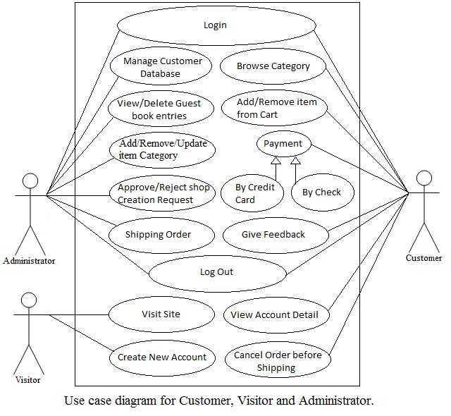
Approve/reject
Admin seller
View/ Remove customer
User
Main admin
PayPal
Admin
Browse Items

- Data Flow Diagram
Level 1
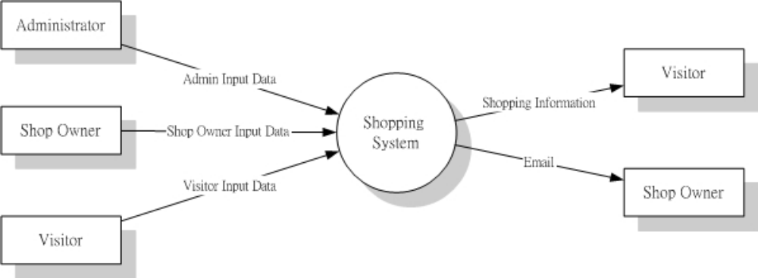

Level 2
